**UMBUY Web Application Guide**

This document walks you through UMBUY web application to introduce the features of the website.

**1.** When you first visit the website, you will see a blank navigation bar with a login button. In order to use UMBUY website, you will have to sign up for it first.

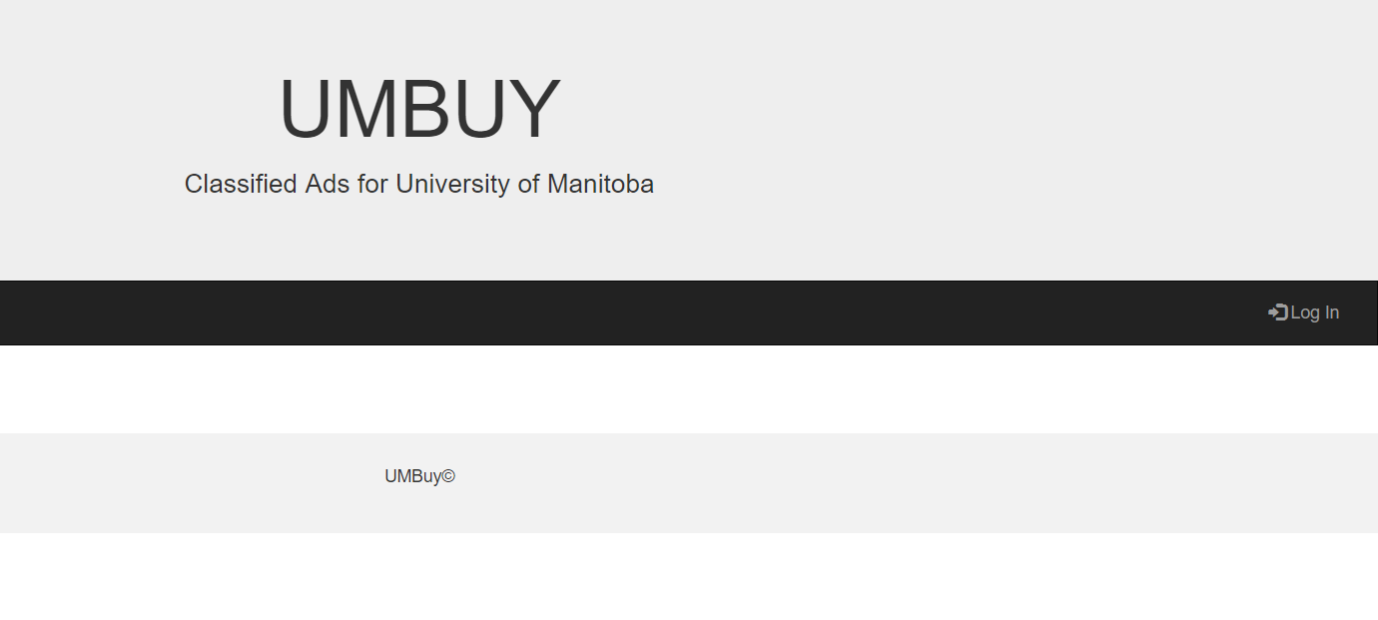

**2.** Please Sign up for the new account or you can use existing email and password to log in

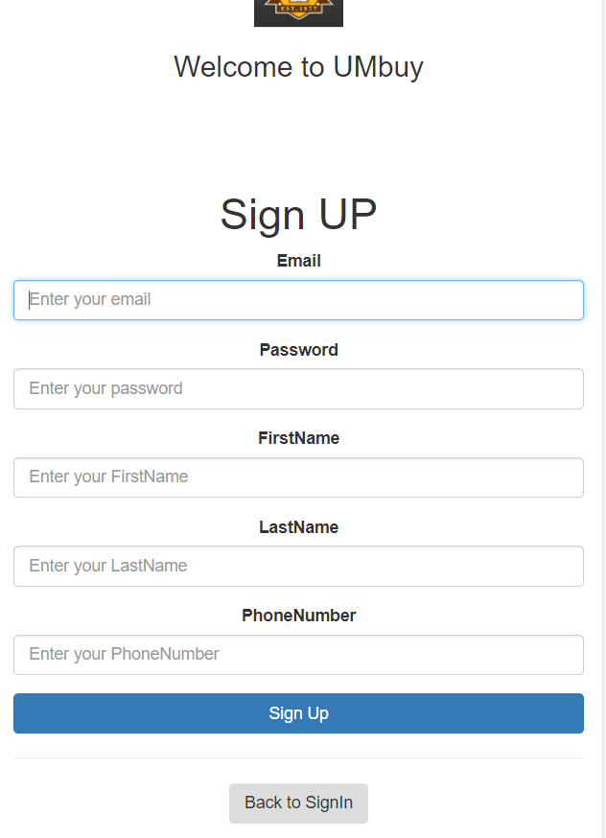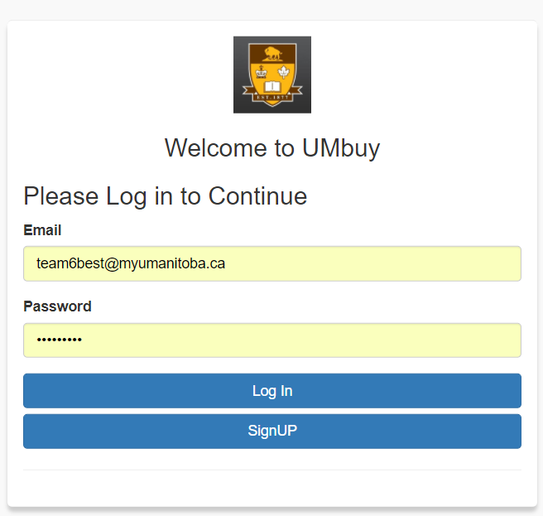**Email**: [team6best@myumanitoba.ca](mailto:team6best@myumanitoba.ca) **Password**: team6best

**3.** Now that you are logged in, you should be able to see the advertisements. Or if you are using localhost.js, then you won’t see any advertisements yet unless you create one.

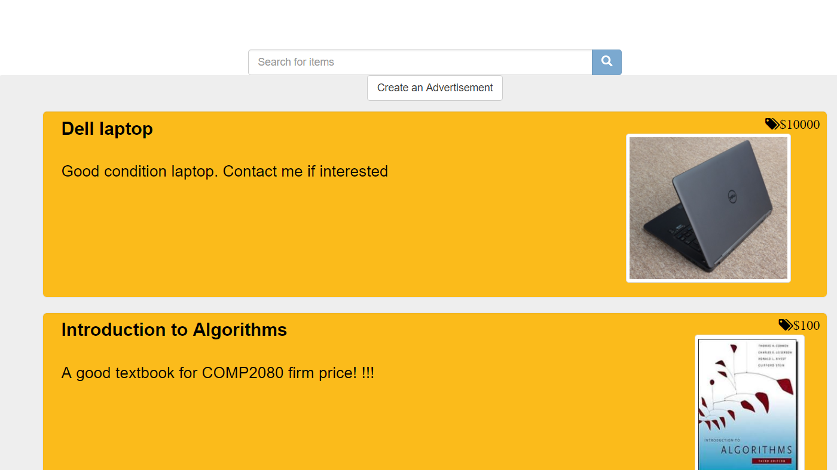

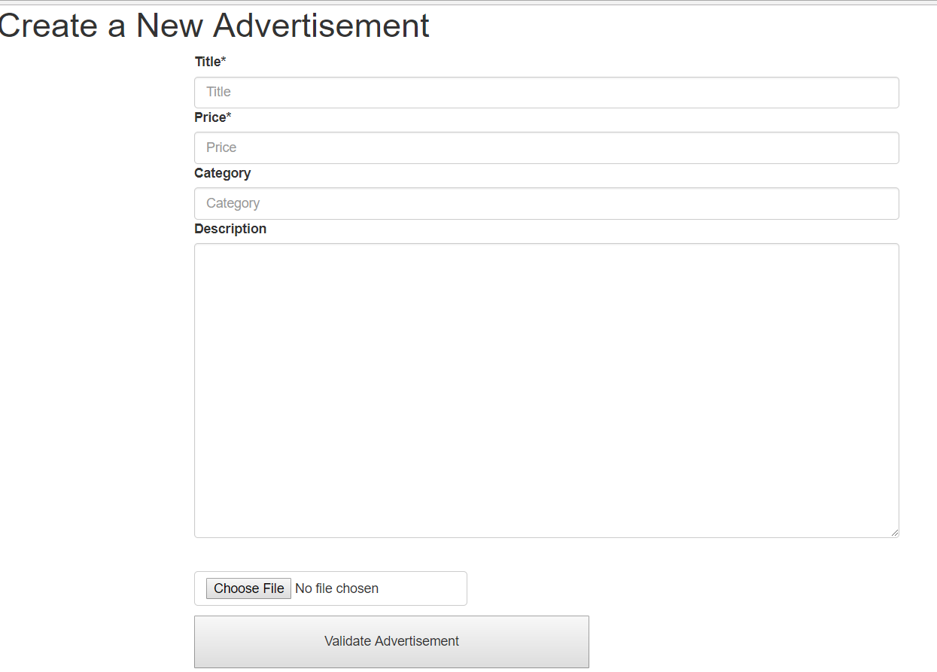**4.** So, let’s first create an advertisement. Only the picture is optional.

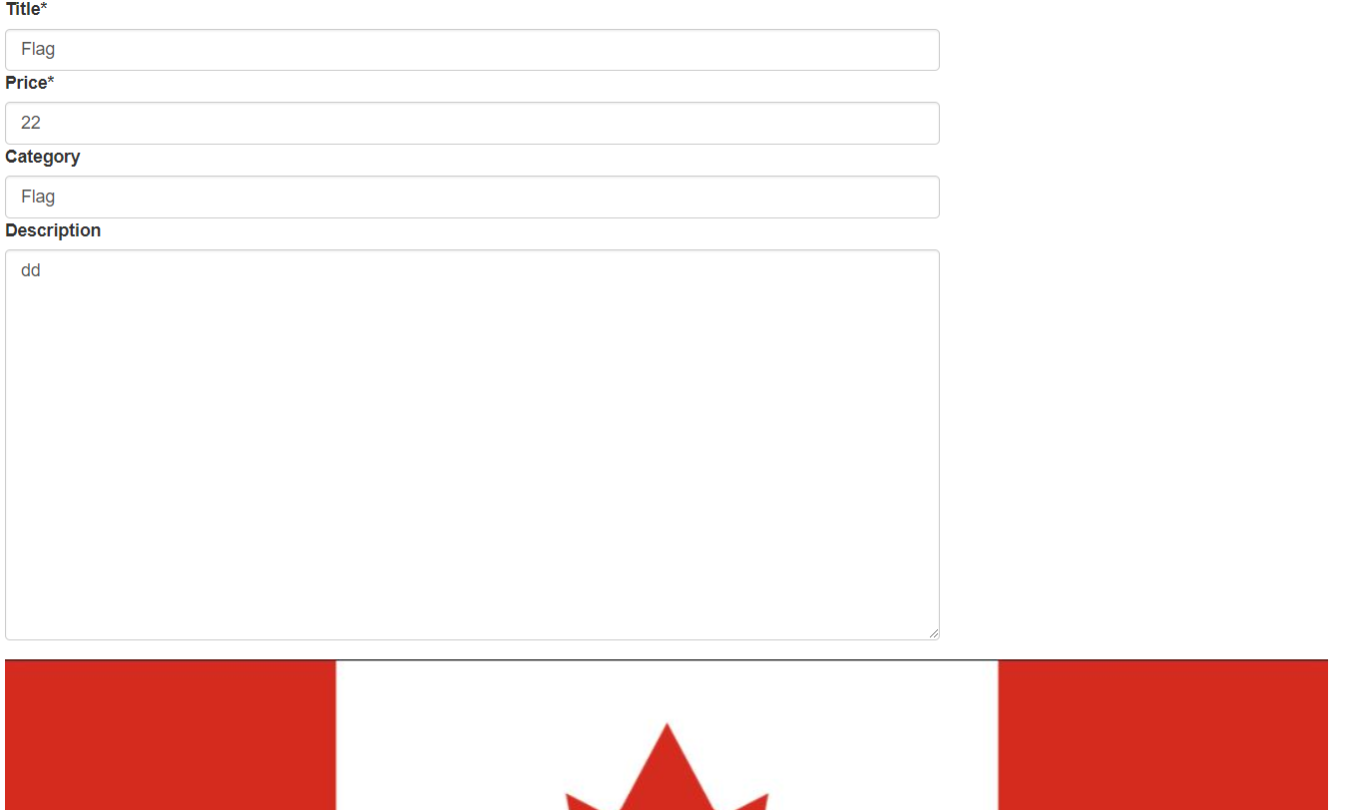**5.** Let’s create an advertisement.

**6.** At the bottom of the page, an advertisement is created.

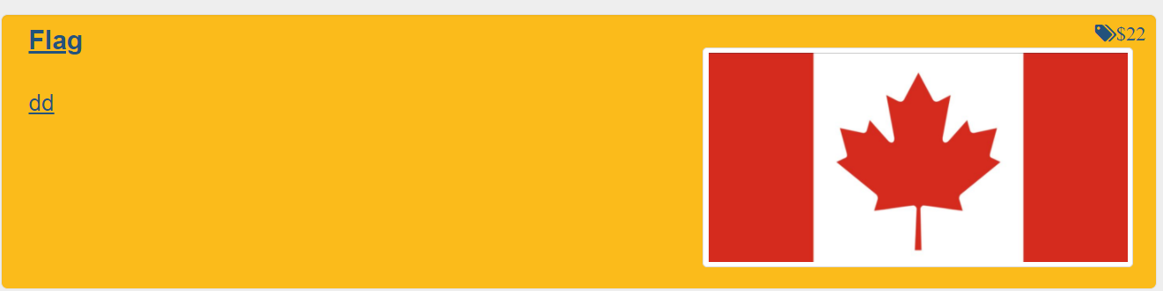

**7.** Now, let’s go to the user account page. Please click on “User Account” button on the navigation bar.

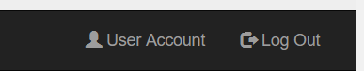

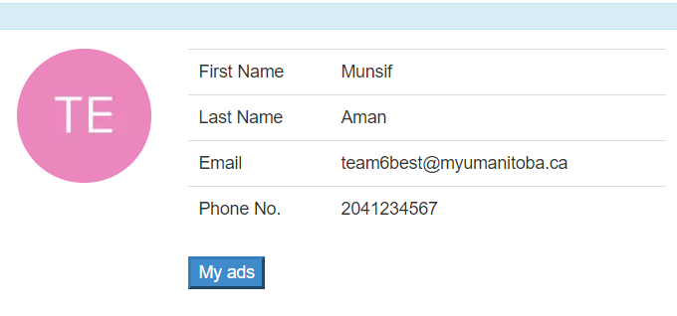**8.** You should be able to see your name, email and phone number. These stand for the user information.

My ads show you the ads posted by you.

Let’s click on My ads.

**9.** Under My Ads, you will see the ads that you posted. Let’s click on one of the ads that you posted.

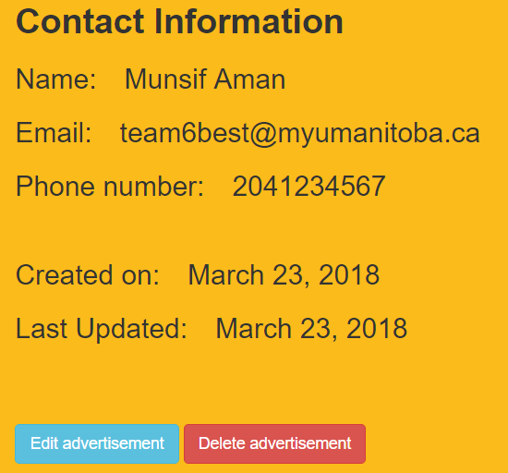 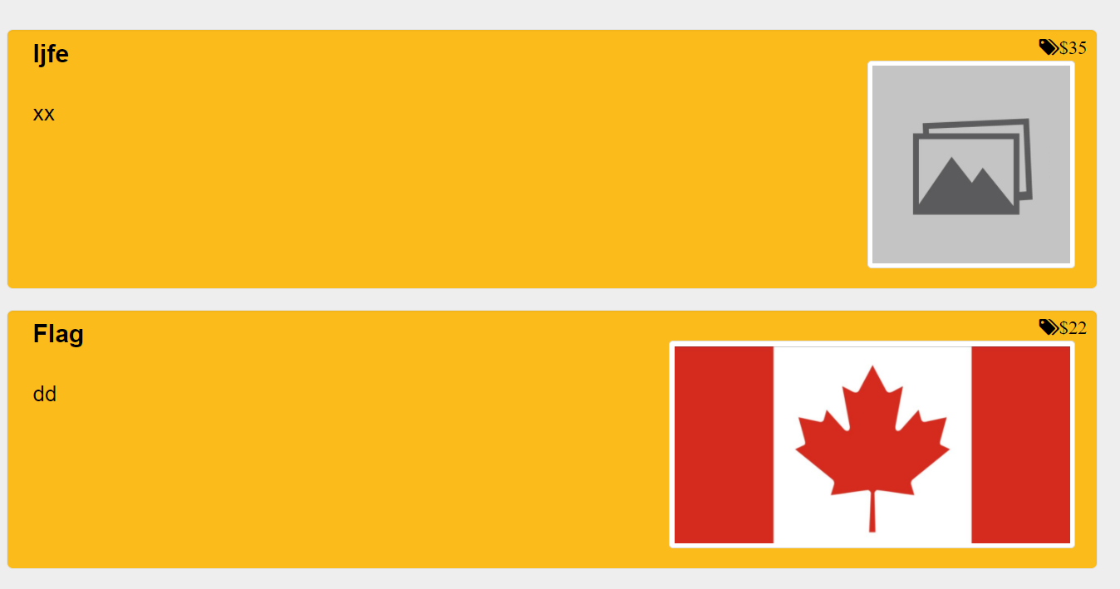**10**. You will be able to see the contact information. Now since this is your ad, you are also able to edit or delete your advertisement. Let’s edit the advertisement first.

**11.** You are able to change title, description, price and category of the advertisement. Please validate and update the advertisement.

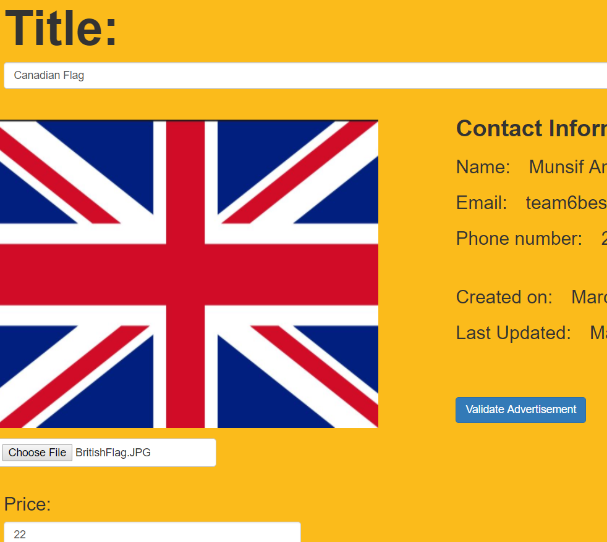

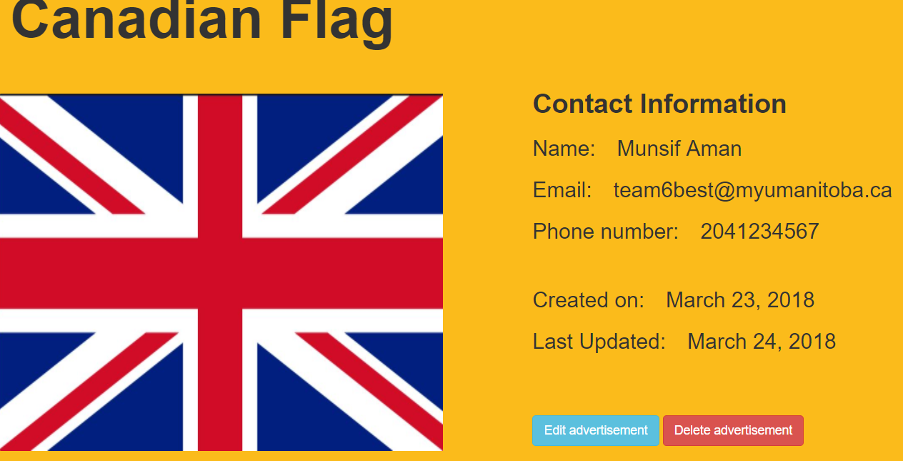**12.** Now you will see that the advertisement is updated. Let’s now delete the advertisement.

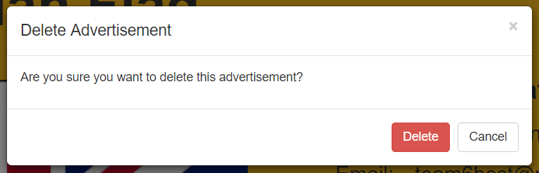**13.** A pop-up will appear to confirm your intent to delete the advertisement.

**14.** Now, let’s try searching for a specific advertisement.



Please enter a title of the advertisement that you want to search. Typo is not allowed, but you can search with partially completed title.

**15.** If you have successfully retrieved the item you want. Click on the advertisement to check the seller’s information.

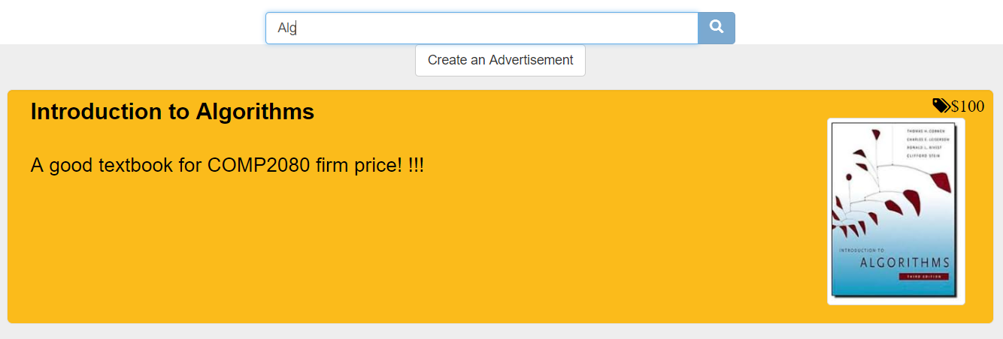

**16.** For this textbook, Ye Yuan is the seller.

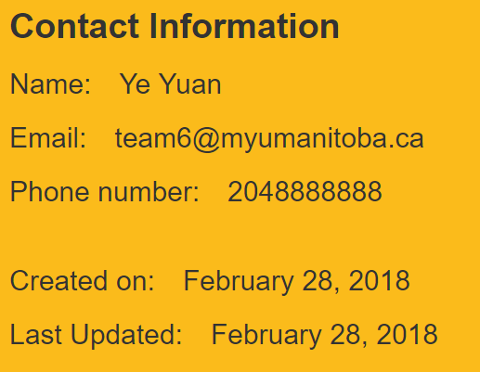

**Thank you for trying our application**. **This is the end of the guide for the website. Please look at the mobile guide if you would like to walk through the mobile application.**